# Project Development Phase

**Delivery of Sprint-1**

|  |  |
| --- | --- |
| **Team ID** | PNT2022TMID47568 |
| **Project Name** | Analytics for Hospitals' Health-Care Data |

**Project Development Phase:**

**Sprint1:**

* Data Collection
* Data Preparation

**Sprint2:**

* Data Exploration

**Sprint-3:**

* Dashboard Creation

**Sprint-4:**

* Report Creation
* Story Creation

**Load the Dataset:**

**Tool used:** IBM Cognos Analytics

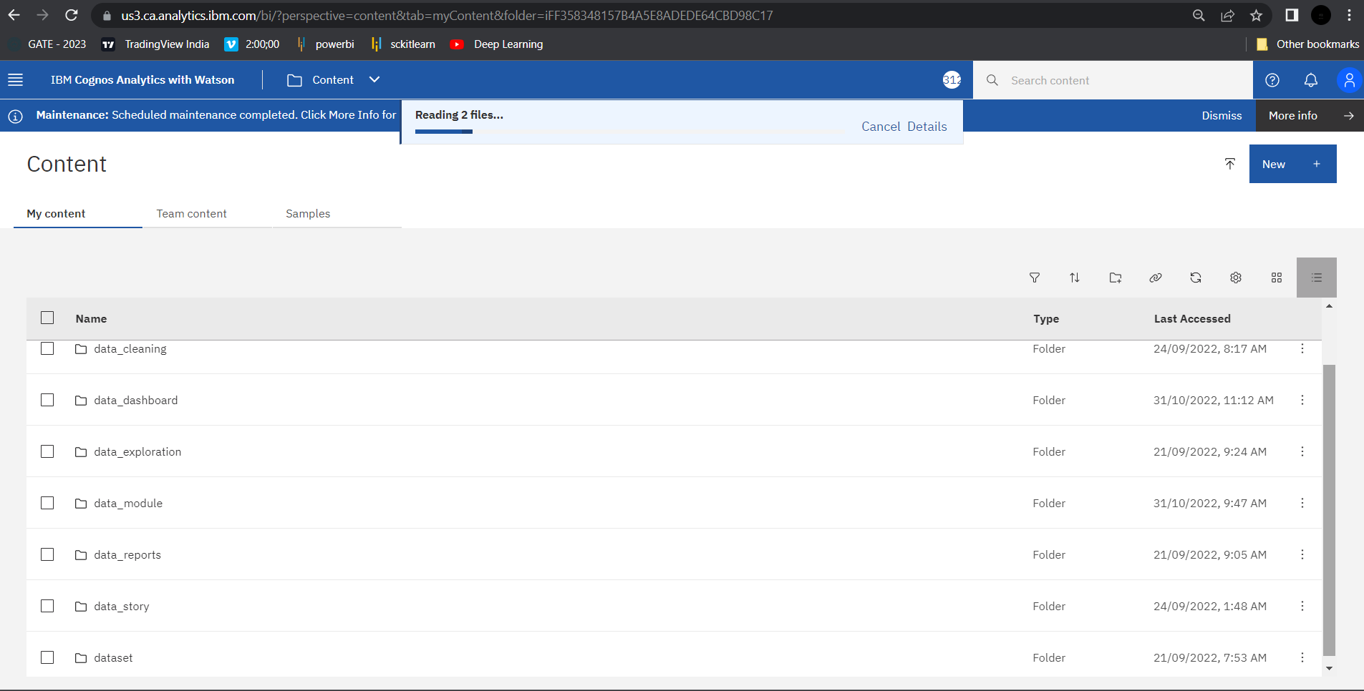

**Data Preparation:**

Prepare the Dataset

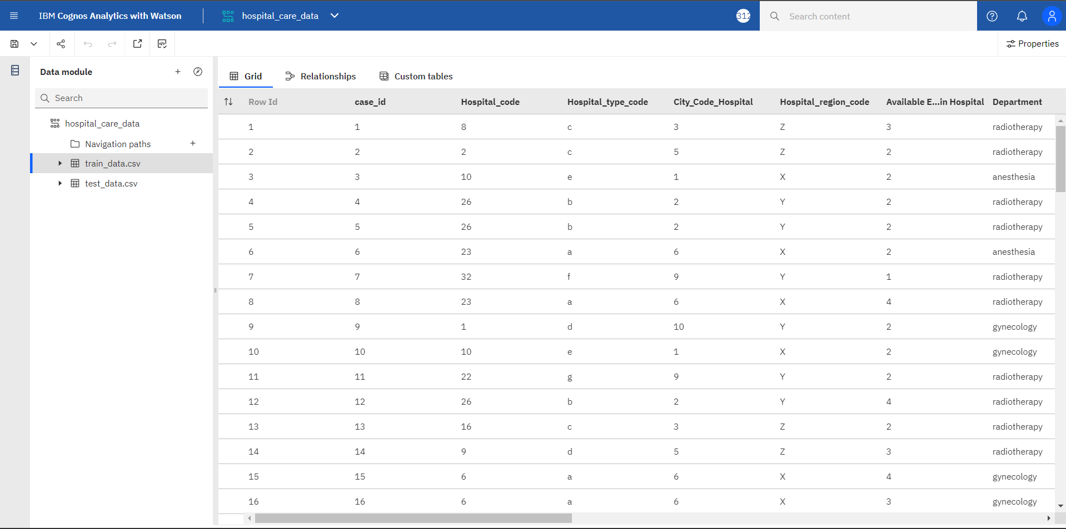

**Null Values Cleaning Process :**

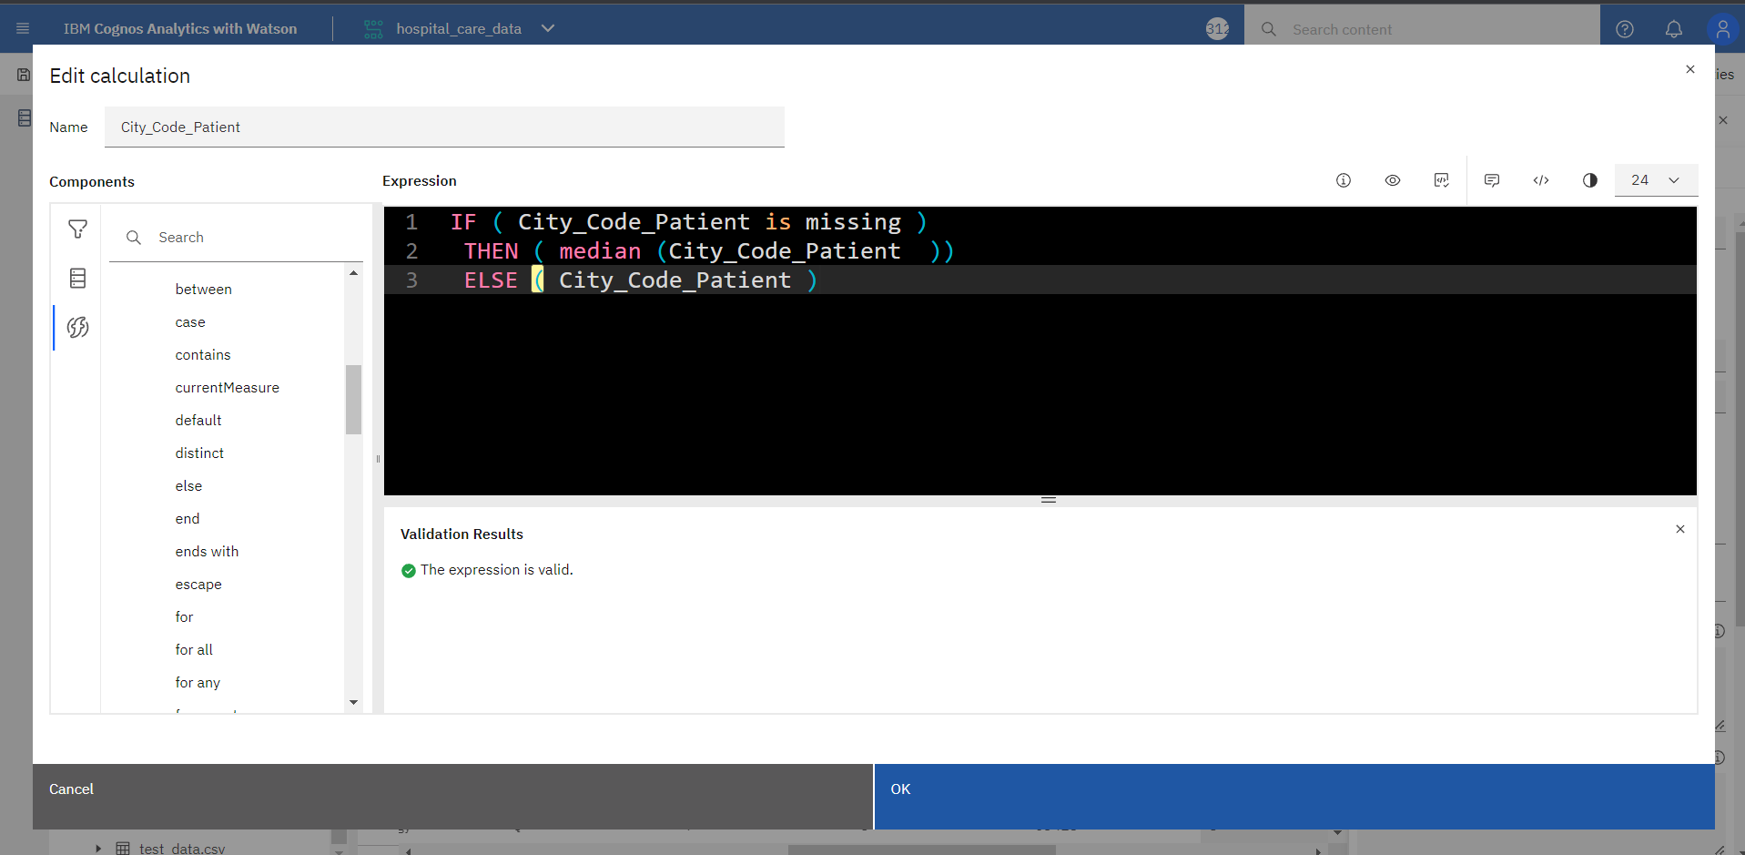

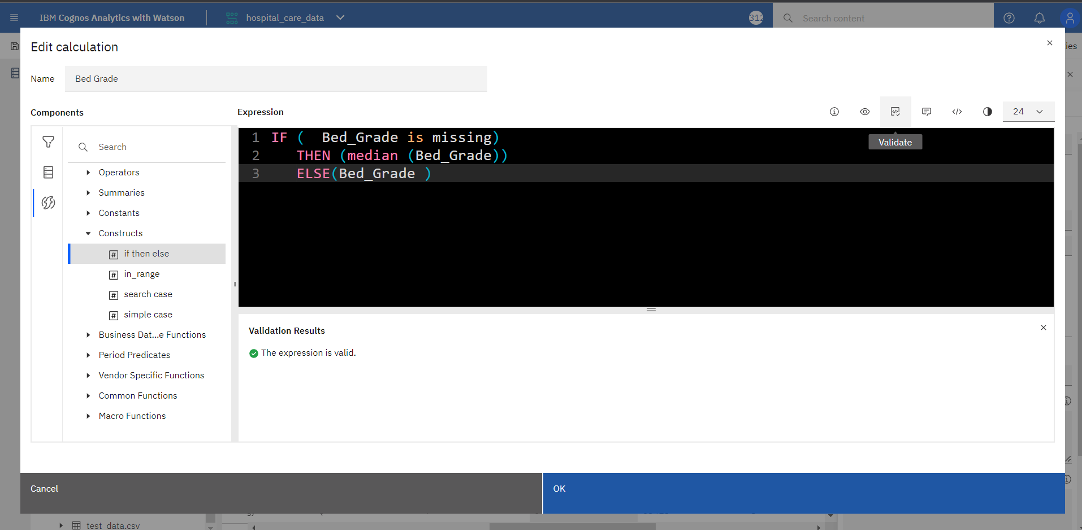

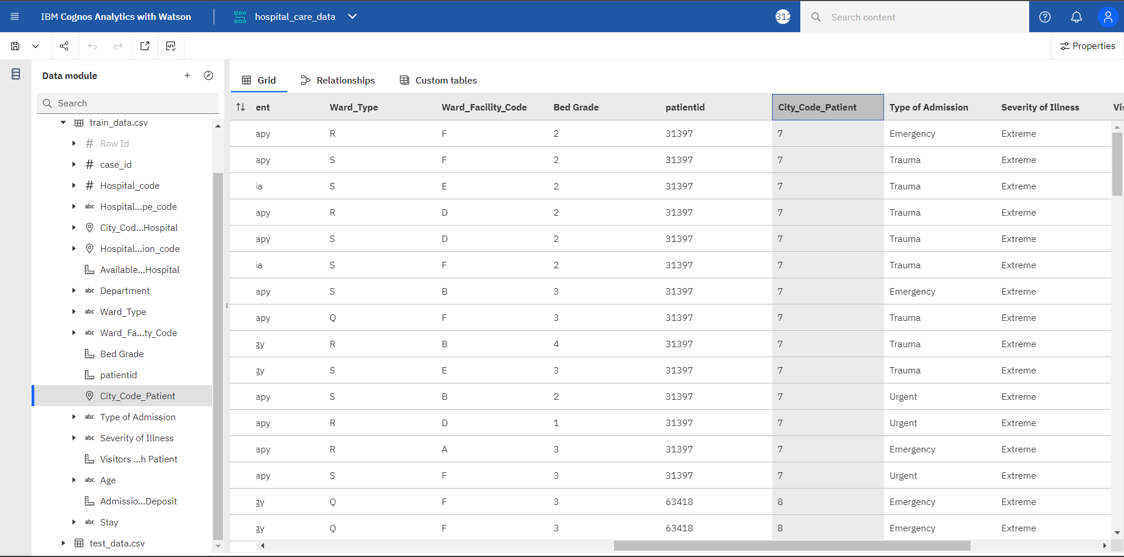

# Hospital Data :

